The American Revolutionary War: History, Causes, Key Events, and Lasting Impact

Table of Contents
Introduction 3
Colonial America Before the Revolution 3
Events Leading to Revolution 4
Causes of the Revolutionary War 5
1. Political Causes 5
2. Economic Causes 5
3. Social and Ideological Causes 5
Key Figures of the Revolution 6
Declaration of Independence 7
Major Battles and Turning Points 8
Life During the War 8
End of the War 9
Immediate and Long-Term Impacts 9
Legacy of the Revolutionary War 10
Timeline of Key Events 10
Conclusion 10

Introduction
The American Revolutionary War was a defining moment in the history of the United States. It marked the shift of thirteen British colonies from colonial rule to an independent nation. Unlike a sudden outbreak of violence, the war was the result of years of political tension, economic conflicts, and philosophical debates over rights and governance. The colonies had grown accustomed to a degree of self-rule and felt increasingly constrained by British policies, which ultimately led them to revolt.
This document explores the period before the war, the events that led to revolution, the key battles and figures, the war’s conclusion, and the lasting impacts that continue to shape the United States today.

Colonial America Before the Revolution
Before 1763, life in the thirteen colonies was marked by both opportunity and restriction. Colonists considered themselves British citizens, yet their lives were different from those in England. Most people lived in rural farming communities, relying on local resources and family labor. Growing cities such as Boston, New York, and Philadelphia became centers of trade, politics, and culture. While colonies had local assemblies and governors, Britain largely allowed them to manage their own affairs, a practice known as “salutary neglect.”
Economically, the colonies were closely tied to Britain. Colonists provided raw materials like timber, tobacco, and cotton, and in return purchased finished goods from British manufacturers. Trade laws such as the Navigation Acts restricted economic activity and manufacturing within the colonies, ensuring that Britain benefited more than the colonies did. This created underlying tension that would later contribute to revolutionary sentiment.

Events Leading to Revolution
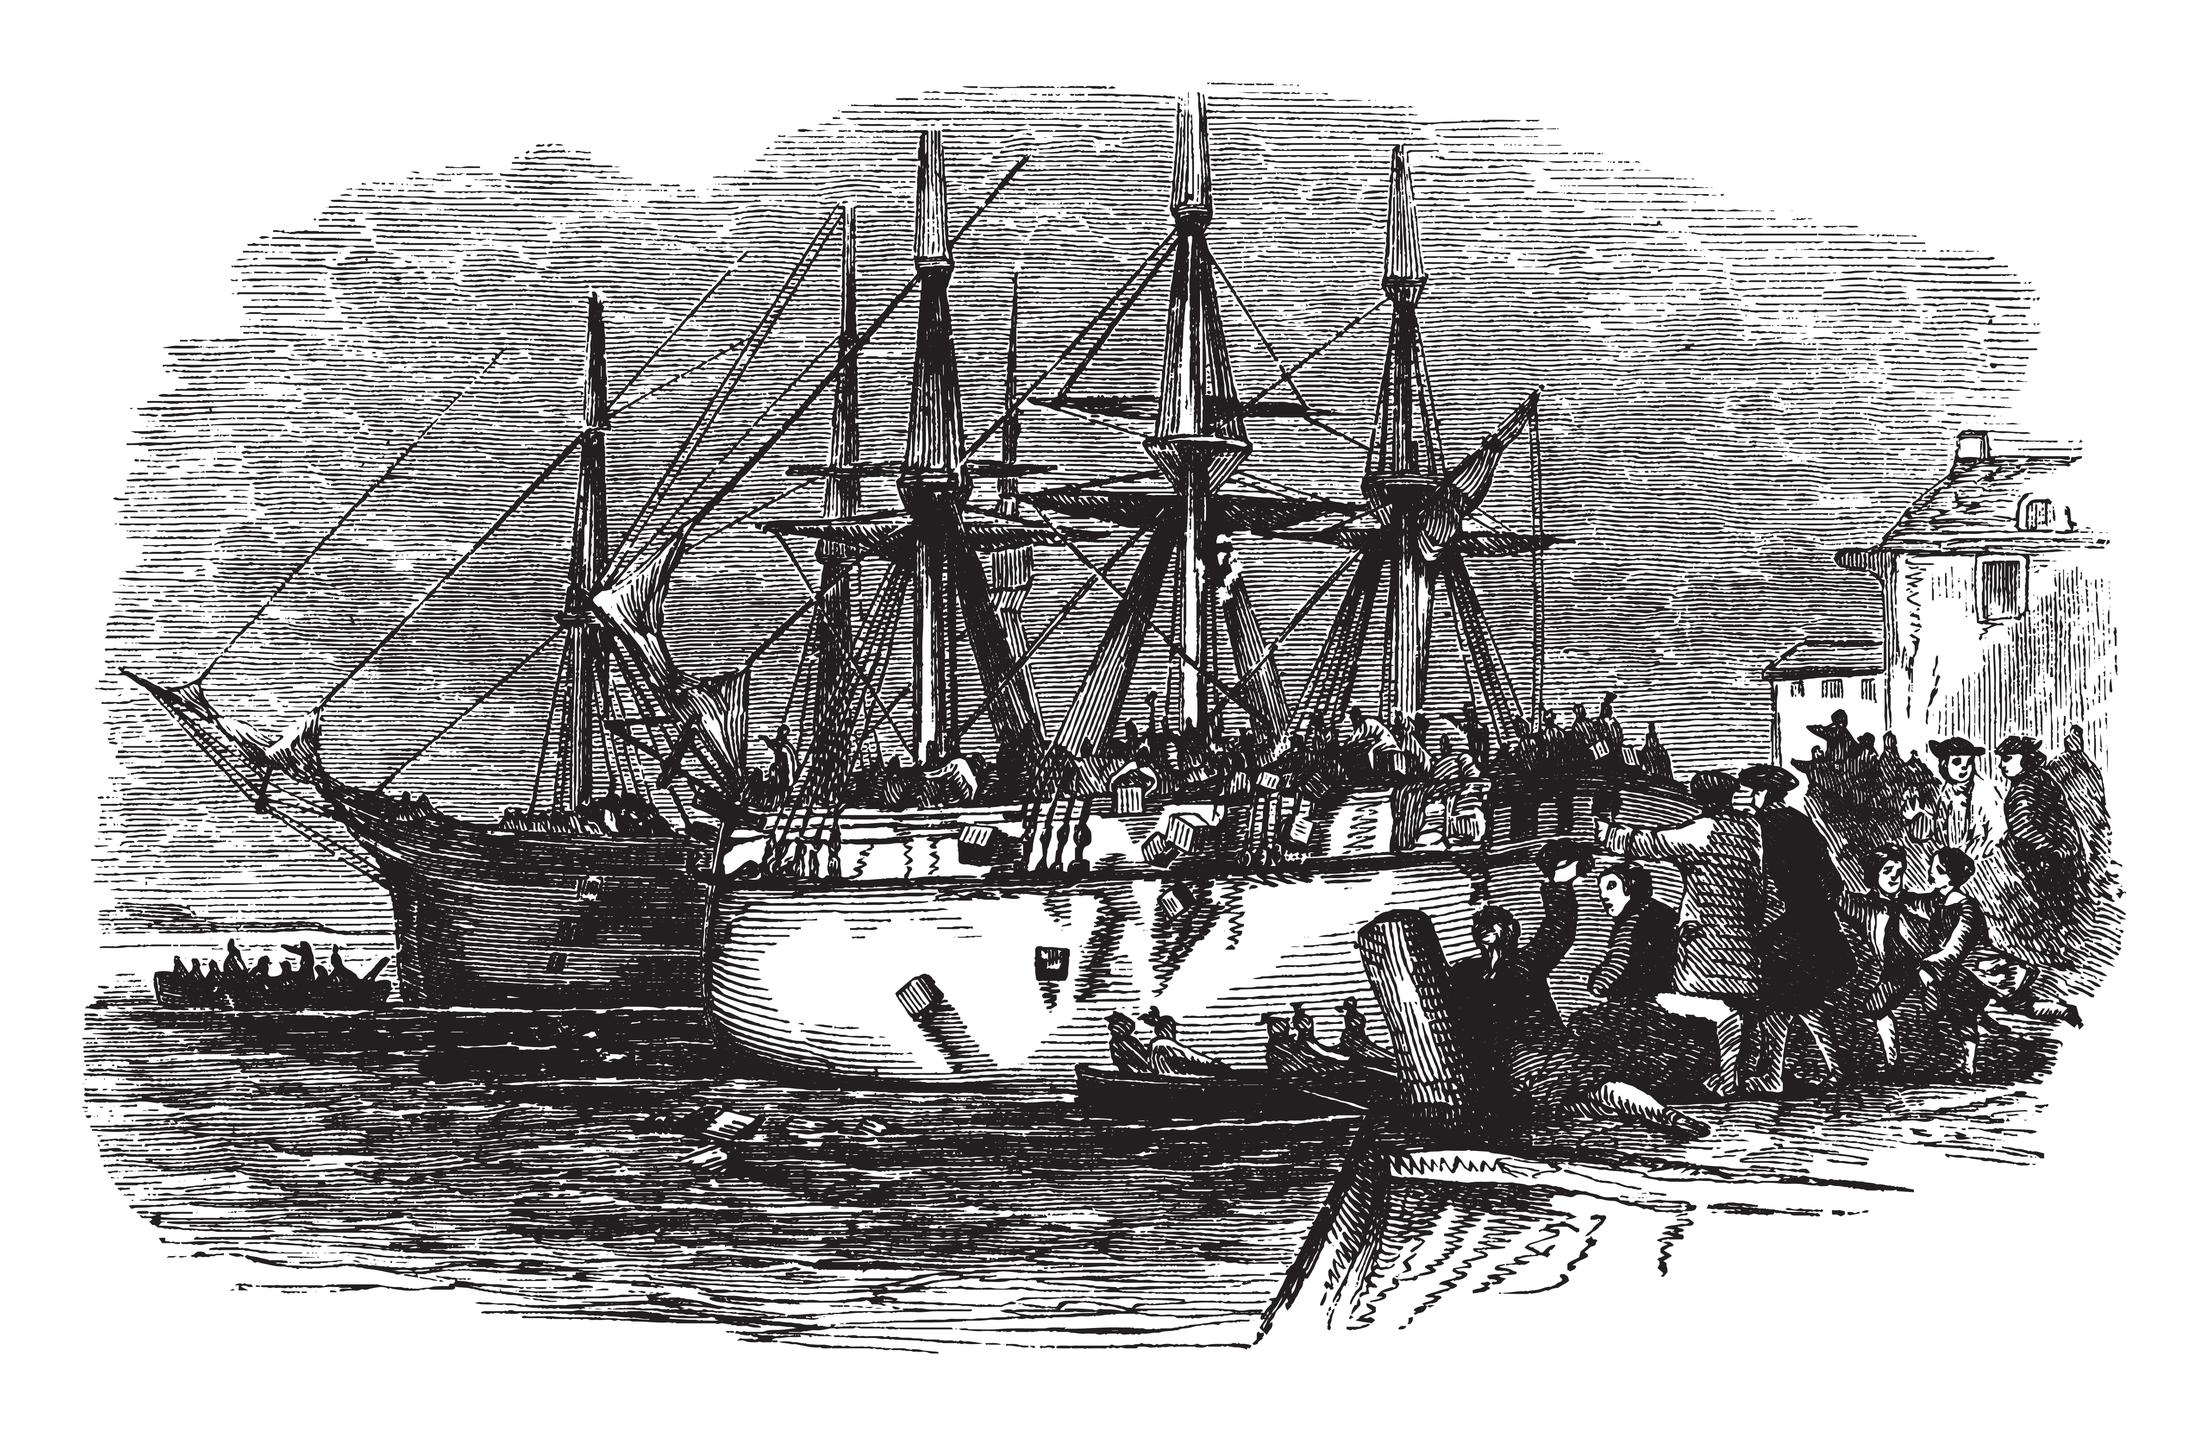
The French and Indian War (1754–1763) significantly changed the relationship between Britain and the colonies. Britain emerged victorious but deeply in debt, prompting the government to increase taxes on the American colonies. This included the Stamp Act of 1765, which taxed all paper goods, and the Townshend Acts of 1767, which imposed duties on imports such as glass, paint, and tea. Colonists argued that taxation without representation violated their rights, giving rise to the famous slogan, “No taxation without representation.”
The colonists’ frustration was further inflamed by violent and symbolic events. In 1770, British soldiers fired on a crowd in Boston, killing five people in what became known as the Boston Massacre. Three years later, the Boston Tea Party saw colonists dumping imported tea into Boston Harbor to protest the Tea Act. In response, Britain passed the Intolerable Acts, punishing Massachusetts by closing Boston Harbor and increasing direct British control over local governance.
The colonies began to organize in response. In 1774, the First Continental Congress met to coordinate resistance, calling for boycotts and asserting colonial rights. When British troops marched to seize weapons in Massachusetts in April 1775, armed conflict erupted at Lexington and Concord, marking the beginning of the Revolutionary War.

Causes of the Revolutionary War
The causes of the Revolutionary War were complex, involving political, economic, and social factors. Politically, the colonies sought self-governance and resented Parliament’s control over their local affairs. Economically, heavy taxes and trade restrictions limited opportunities and fostered resentment. Socially, Enlightenment ideas inspired colonists to value individual rights and question the authority of monarchy. Thinkers such as John Locke influenced revolutionary leaders to argue that people have a right to overthrow governments that fail to protect their liberties.
Some of the major causes can be summarized as follows:

Political Causes
  - Lack of colonial representation in British Parliament
  - Increasing British interference in local governance

Economic Causes
  - Heavy taxation without consent
  - Restriction of trade and manufacturing

Social and Ideological Causes
  - Spread of Enlightenment ideas
  - Belief in natural rights and self-determination

Key Figures of the Revolution
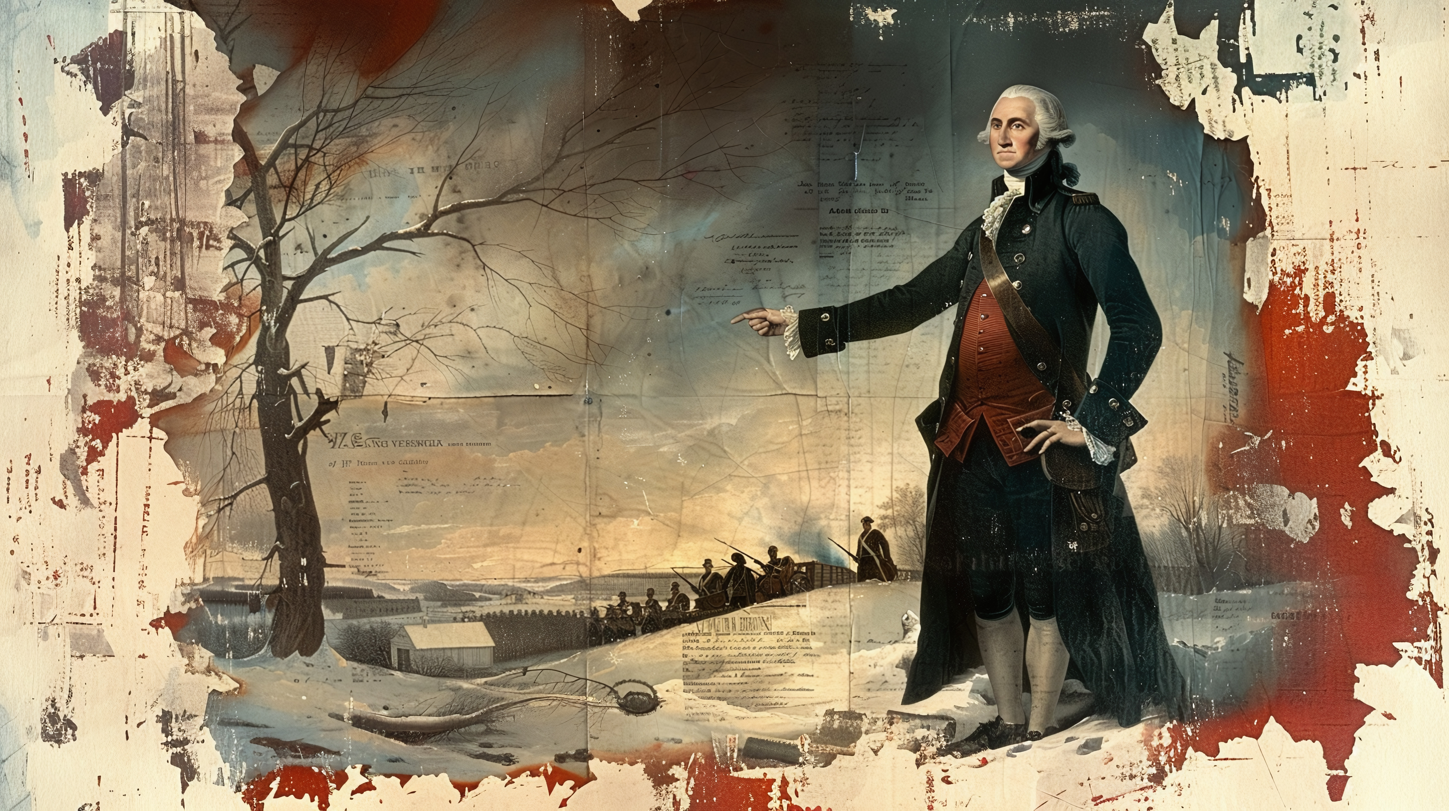
The Revolutionary War featured leaders whose decisions and actions shaped the course of history. George Washington commanded the Continental Army with courage and perseverance. King George III, as Britain’s monarch, oversaw the government’s response, often underestimating colonial resistance. Thomas Jefferson drafted the Declaration of Independence, articulating the colonists’ reasons for rebellion, while Benjamin Franklin and John Adams worked tirelessly as diplomats, securing crucial foreign support.
Other notable figures include:
- Alexander Hamilton, aide to Washington and key organizer of the army
- Paul Revere, whose midnight ride warned of British troop movements
- John Hancock, prominent patriot and early supporter of independence

Declaration of Independence
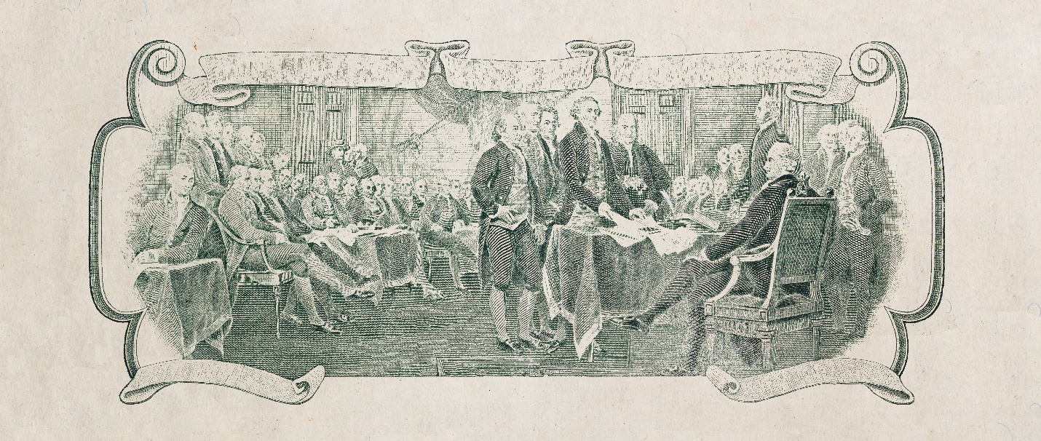
On July 4, 1776, representatives of the thirteen colonies formally declared their independence from Britain. Drafted mainly by Thomas Jefferson, the Declaration of Independence outlined the philosophical justification for rebellion, emphasizing that all men are created equal and that governments exist to protect the rights of the people. If a government becomes oppressive, citizens have the right to alter or abolish it.
You can read the full text of the Declaration of Independence at the National Archives: Declaration of Independence (1776).

Major Battles and Turning Points
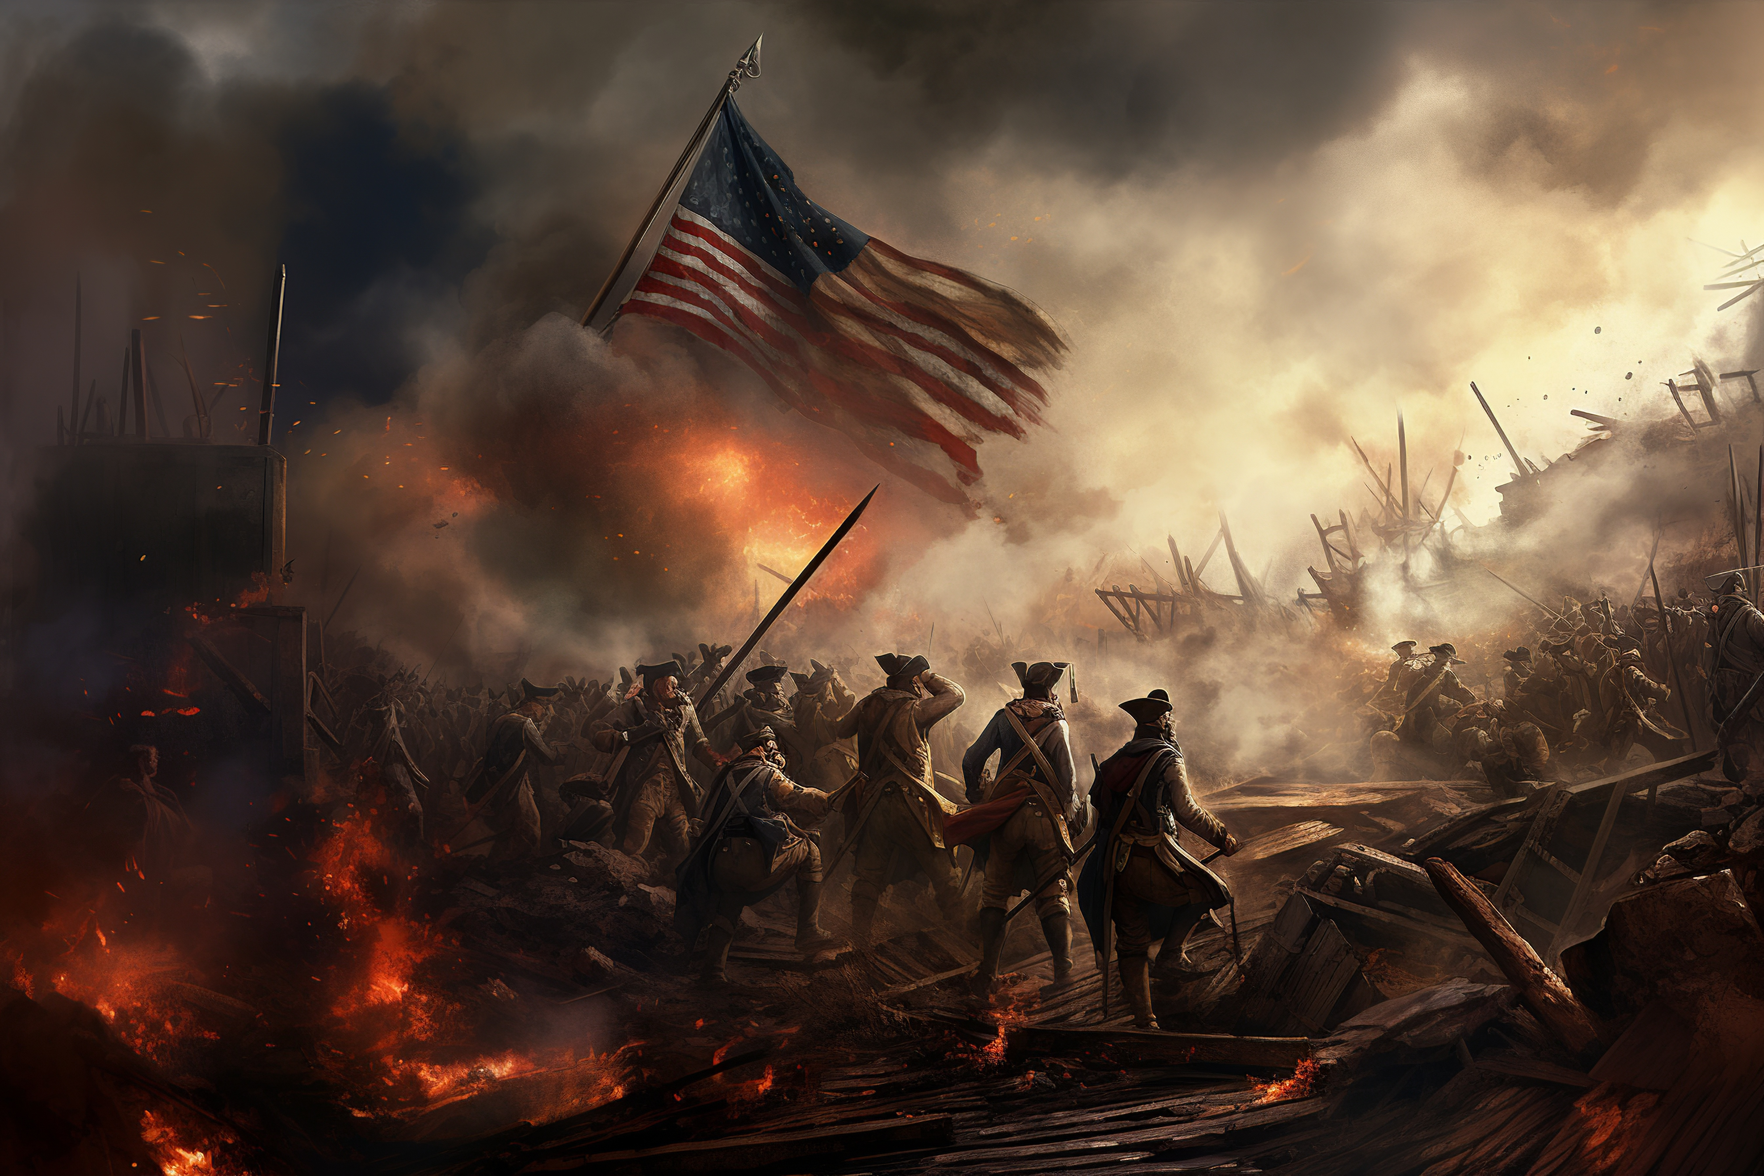
The Revolutionary War included several key battles that determined the course of the conflict. The early clashes at Lexington and Concord and the Battle of Bunker Hill demonstrated colonial resilience. A turning point occurred in 1777 at the Battle of Saratoga, where the American victory convinced France to support the colonies with troops, money, and supplies—a contribution that proved essential to ultimate success.
The war relied heavily on alliances. France’s involvement, along with Spain and the Netherlands to a lesser extent, provided critical naval support and financial resources. The combined American and French forces finally forced British General Cornwallis to surrender at Yorktown in 1781, effectively ending major hostilities.

Life During the War
The war affected both soldiers and civilians profoundly. Soldiers faced poor supplies, harsh winter conditions, and extended absences from their families. Civilians endured shortages of food and basic goods, and communities were often divided between Patriots, who supported independence, and Loyalists, who remained faithful to Britain. Despite these hardships, the colonies developed a sense of unity and shared purpose that contributed to the war effort.

End of the War
The war formally ended with the Treaty of Paris in 1783. This treaty recognized the United States as an independent nation, established borders, and promised to resolve outstanding issues between Britain and the colonies.
Key provisions of the treaty included:
- Recognition of American independence
- Establishment of borders from the Atlantic Ocean to the Mississippi River
- Restoration of property and rights for Loyalists where possible
You can read the full text of the Treaty of Paris (1783) at the National Archives:
Treaty of Paris (1783).

Immediate and Long-Term Impacts
The war’s immediate aftermath presented challenges. The newly independent United States initially operated under the Articles of Confederation, which created a weak national government. Economic instability and disagreements among states revealed the need for a stronger federal system. This led to the drafting of the U.S. Constitution in 1787, creating a federal government with checks and balances to protect individual freedoms.
The Revolutionary War also inspired democratic movements worldwide and set a precedent for challenging oppressive rule. However, many groups, including women, Native Americans, and enslaved people, were left without rights. Over time, amendments and legislation gradually extended civil liberties.
You can read the full text of the U.S. Constitution at the National Archives:
U.S. Constitution

Legacy of the Revolutionary War
The principles of the Revolution still shape the United States today. Ideas of freedom, representative government, and the rule of law remain central to American society. Elections, the written Constitution, and the protection of individual rights are direct legacies of the revolutionaries’ vision. Globally, the American Revolution influenced other movements for independence and democracy, such as the French Revolution and Latin American independence movements.

Timeline of Key Events
Year | Event
1763 | End of the French and Indian War
1773 | Boston Tea Party
1775 | Lexington and Concord; start of the war
1776 | Declaration of Independence
1777 | Battle of Saratoga
1781 | Battle of Yorktown
1783 | Treaty of Paris; formal end of war

Conclusion
The American Revolutionary War was more than a military conflict; it was a struggle over governance, rights, and identity. Its effects continue to shape the United States and the world. By understanding the events, causes, and consequences of the Revolution, we gain insight into the development of democracy, civil rights, and the ongoing pursuit of liberty and equality.

